BALLISTICS AND TOOL MARKS GLOSSARY OF TERMS

1. Firearms Identification: Is the discipline of forensic science that has as its primary

concern to determine if a bullet, cartridge case or other ammunition component was

fired by a particular firearm.

2. Toolmarks Identification: Is the discipline of forensic science that has as its primary

concern to determine if a toolmark was produced by a particular tool.

3. Tool: An object used to gain mechanical advantage. Also thought of as the harder of two

objects, which when brought into contact with each other, results in the softer one being

marked.

4. Fired Bullet(s): A bullet which has been fired from a firearm. ( NOT : spent bullet,spent slug, or spent round)

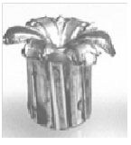
5. Fired Cartridge Case(s): A cartridge case which has been fired. (NOT: spent casing,loose round, empty round)

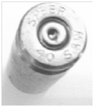
6. Loaded Cartridge(s): A single unit of ammunition consisting of the case, primer, and
propellant with or without one or more projectiles. (NOT: loaded bullet, live round, or loaded round)

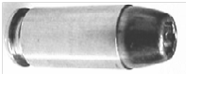
7. Loaded Shotshell: A cartridge containing projectile(s) designed to be fired in a shotgun.
The cartridge body may be metal, plastic, or paper.

8. Shot: Spherical pellets used in loading shotshells or cartridges.
(see illustration blank arrows)
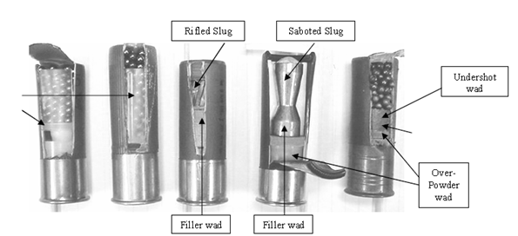

9. Rifle: A firearm having rifling in the bore and designed to be fired from the shoulder.

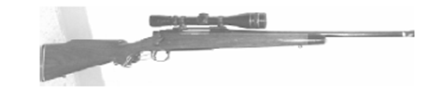

10. Revolver: A firearm, usually a handgun, with a cylinder having several chambers so
arranged as to rotate around an axis and be discharged successively by the same firing
mechanism.

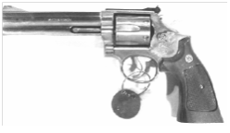

11. Pistol: A handgun in which the chamber is part of the barrel

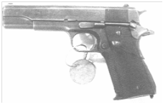

12. Shotgun: A smooth bore firearm designed to be fired from the shoulder. The shotshell
can contain numerous pellets or sometimes a single projectile.
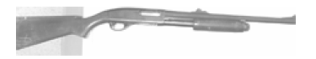

13. Short Barreled Rifle: A “sawed-off” rifle that has a barrel length of less than 16 inches
or its overall length is less than 26 inches.

14. Short Barreled Shotgun: A “sawed-off” shotgun that has a barrel of less than 18 inches
or its overall length is less than 26 inches.

